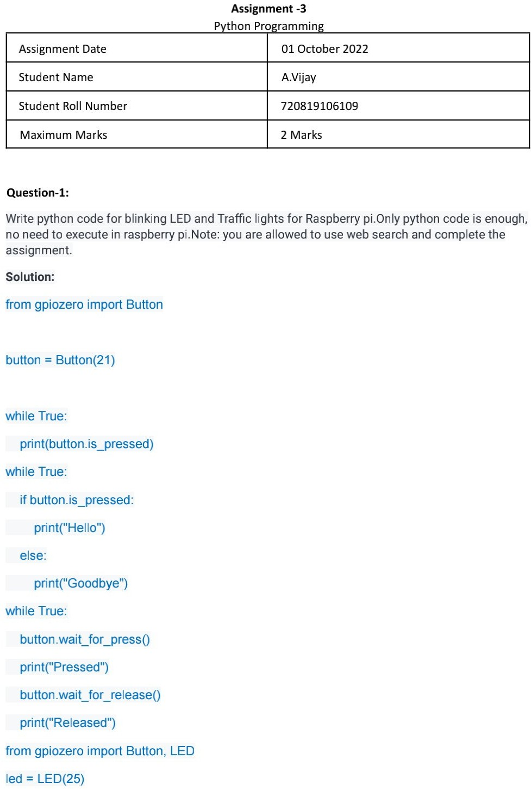

110719106019

M Venkata Pavan Kumar

110719106018

M pavan kumar

2 Marks

110719106039

Y Balaji

01 October 2022

